Eclipse is a Java-based application and it requires a Java runtime environment (JRE) to be installed in order to run. Install the default OpenJDK package with:
step-1
sudo apt install default-jre

step-2
Download and install the Eclipse snap package on your system, by typing

sudo snap install --classic eclipse

On successful installation of Eclipse, you should see the following output:
eclipse 2019-03 from Snapcrafters installed

Starting Eclipse
Now that Eclipse is installed on your Ubuntu system you can start it by clicking on the Eclipse icon (Activities -> Eclipse):


When you start Eclipse for the first time, a window like the following will appear asking you to select a Workspace directory:

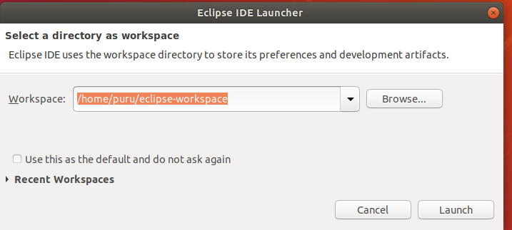

The default directory should be fine. Click Launch to proceed:
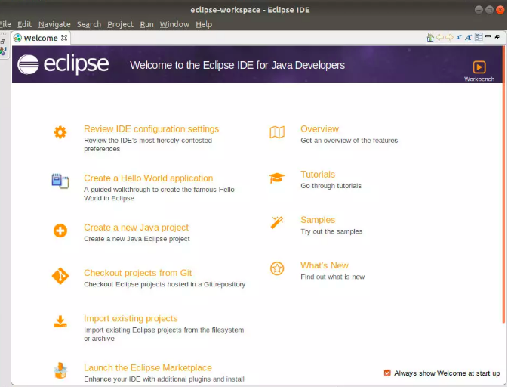

Conclusion
You have learned how to install Eclipse on your Ubuntu 18.04 machine. You can now start working on your Java project.

Thanks
Puru sharma

